Requirements and Design of Inventory Management System

1. Introduction
The Inventory Management module plays a critical role in ensuring that manufacturing operations run smoothly by maintaining accurate records of materials, stock levels, and transactions. It acts as the central system for tracking resources, coordinating with suppliers, and supporting production jobs with timely material availability.
Once a job is created in the Job Management module, this system checks whether the required materials are available. If not, it triggers alerts and initiates procurement. This ensures that production never halts due to stock shortages.

2. Functional Requirements

2.1. Material Management
Users can add new materials with attributes like name, type, size, and unit. These entries form the foundation of the inventory system. Whenever a new product is introduced or a supplier changes specifications, the material master can be updated. If a material becomes obsolete, it can be removed to keep the database clean.

2.2. Inventory Management
The system continuously monitors stock levels. After every stock-in (supplier delivery) or stock-out (job request), the inventory is updated automatically. This ensures that managers always see the latest quantities and can make informed decisions.

2.3. Transaction Management
Every movement of material — whether incoming or outgoing — is logged as a transaction. These records include the date, quantity, type (stock-in or stock-out), and job reference. This history helps in audits, tracking usage patterns, and identifying bottlenecks.

2.4. Supplier Management
Suppliers are linked to specific materials. The system stores their contact details, lead times, and delivery history. When stock falls below a threshold, the system can automatically generate a purchase order and send it to the appropriate supplier.

2.5. Alert & Notification System
Thresholds are defined for each material. When stock drops below these levels, alerts are triggered. Notifications are sent to the Inventory Manager via dashboard popups, emails, or SMS, depending on urgency.

2.6. Reporting & Analytics
The system generates reports showing material usage, stock trends, supplier performance, and job fulfillment status. These reports help managers plan better, negotiate with suppliers, and optimize inventory levels.

2.7. User & Role Management
Access is controlled based on roles:
- Inventory Manager: Full access to stock, suppliers, and transactions
- Production Manager: Can view inventory and request materials
- Job Manager: Can initiate material requests for jobs Each action is logged for accountability.

3. Non-Functional Requirements
3.1.Performance:
The system is optimized to handle over 10 users simultaneously. Inventory updates occur in under 2 seconds, and reports are generated within 5 seconds for standard queries.
3.2.Scalability:
As operations grow, the system can support atleast 100 transactions.
3.3.Security:
Role-based access ensures that only authorized users can view or modify sensitive data. JWT authentication secures login sessions, and all supplier and transaction data is encrypted.
3.4.Reliability:
With 99.9% uptime, the system ensures continuous availability.
3.5.Usability:
Dashboards are designed to be clear navigation and responsive layouts. Managers can access the system from desktops or mobile devices.
3.6.Maintainability:
The codebase follows a modular structure, separating frontend, backend, and database logic. This makes it easy to update business rules or add new features.
3.7.Monitoring:
Real-time monitoring tools track inventory levels and system health.

4. System Architecture
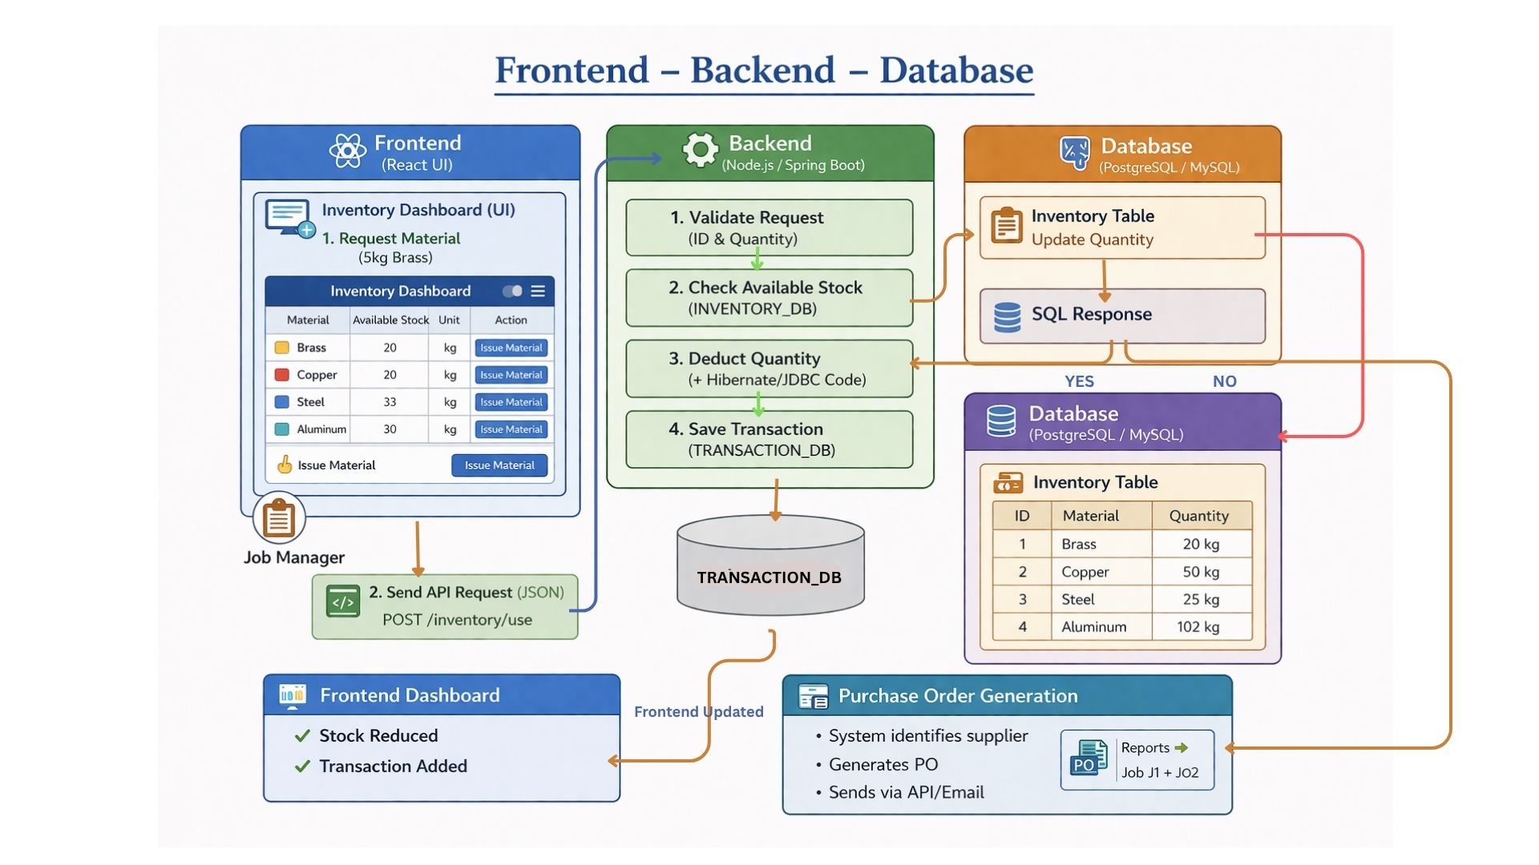

4.1.User Interaction (Frontend)
- The process starts with the Job Manager
- He requests material (e.g., 5 kg Brass) using the Inventory Dashboard
What happens:
- User clicks “Issue Material”
- Data is prepared in UI

4.2.API Request
- Frontend sends request to backend using API

Example:
POST /inventory/use
- Data sent in JSON format

4.3: Backend Processing (Core Logic)
Backend (Node.js) performs:
- Validate request: Checks material name & quantity
- Check Available Stock : Reads data from Inventory Database
- Deduct Quantity : Reduces stock if available
- Save Transaction : Stores record in Transaction Table

4.4: Database Operations
Database (MySQL/PostgreSQL):
- Updates Inventory Table
  - Example: Brass → 20 kg → 15 kg
- Stores transaction:
  - Type: OUT
  - Quantity: 5 kg
  - Job ID
- Sends response back to backend

4.5: Response to Frontend
Backend sends response:
- Success → “Material Issued”
- Failure → “Insufficient Stock”

4.6.UI Update (Dashboard)
Frontend updates automatically:
- Stock is reduced
- New transaction added
- Dashboard reflects real-time data

4.7.Purchase Order Generation
If stock is low:
- System triggers alert
- Generates Purchase Order (PO)
- Sends to supplier
5.Interface Design of Inventory Management System
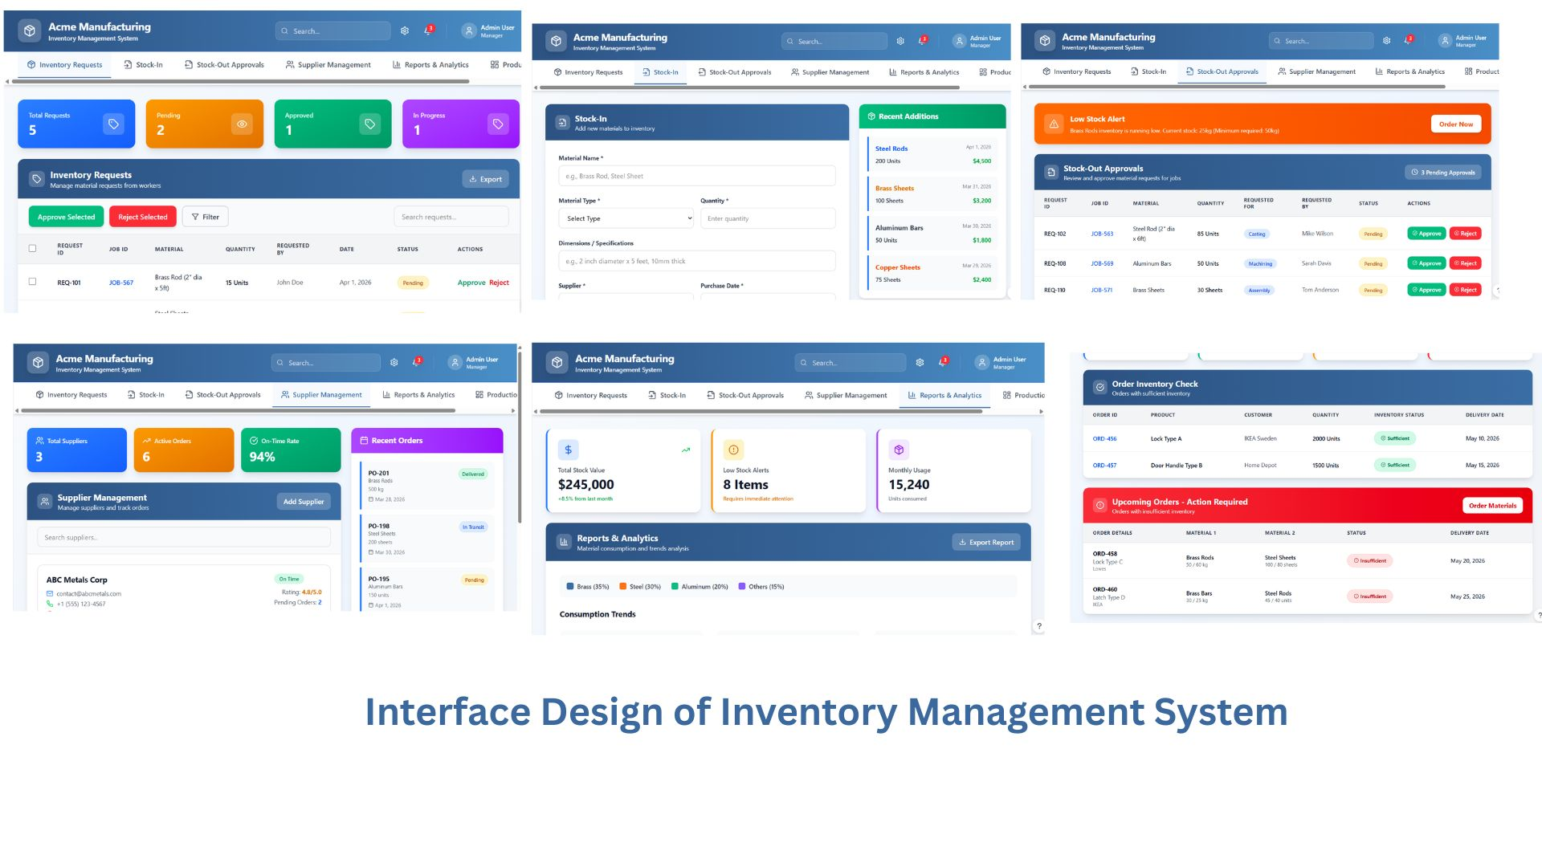

5.1.Inventory Requests
- Dashboard shows Total Requests, Pending, Approved, In Progress
- Table lists request IDs, materials, quantities, and dates
- Managers can Approve/Reject requests instantly

5.2.Stock-In
- Form to record new material deliveries (name, type, quantity, specs, supplier)
- Recent Additions list highlights latest materials added (e.g., Steel Rods, Brass Sheets)
- Ensures accurate and timely updates to inventory

5.3.Stock-Out Approvals
- Dashboard for approving material usage requests from jobs/production
- Low Stock Alert banner warns when items fall below threshold
- Approve/Reject buttons streamline decision-making

5.4. Supplier Management
- Metrics: Total Suppliers, Active Orders, On-Time Rate
- Supplier profiles with contact details and ratings
- Helps track supplier performance and reliability

5.5. Reports & Analytics
- Key metrics: Total Stock Value, Low Stock Alerts, Monthly Usage
- Consumption trends chart (e.g., Steel 37%, Aluminum 29%)
- Supports better planning and procurement decisions

5.6. Order Inventory Check
- Table of orders with product, customer, quantity, inventory status, delivery date
- Highlights Upcoming Orders requiring action
- Red “Order Materials” button for quick procurement

6. Tech Stack
- Frontend: React — fast, component-based UI ideal for dashboards
- Backend: Node.js + Express — lightweight
- Database: PostgreSQL — strong relational consistency and performance
- Auth: JWT — secure, role-based access control
- Deployment: AWS

